CM3070 – Final Project

Midterm Report

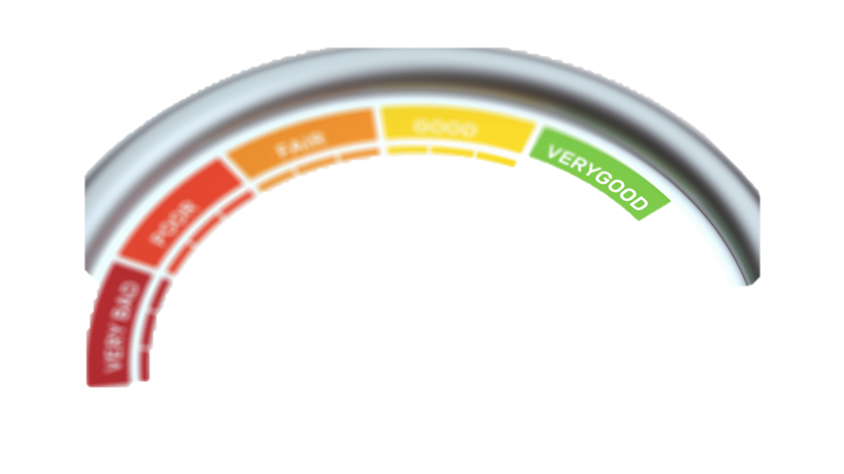

**Feelings-Score**

Project template **CM3015 Machine Learning and Neural Networks**,

titled "**Deep Learning on a Public Dataset”**

Table of Contents

List of Figures 3

Vision Statement 4

Introduction 5

Similar projects and products 5

iMotion -  human behaviour research software 5

EmoReact 6

NoldusHub: 6

Project Ethics 6

Informed Consent: 6

Confidentiality and Anonymity: 6

Voluntary Participation: 7

Data Protection and Security: 7

Respect for Diverse Perspectives: 7

Beneficence and Minimising Harm: 7

Transparency and Openness: 7

Literature review 8

Title: Development of Strategies for Automatic Facial Feature Extraction and Emotion Recognition 8

Introduction: 8

Summary of the Research Paper 8

Facial Feature Extraction Techniques 8

Emotion Recognition: 8

Discussion and Analysis: 9

Evaluation and Results: 9

Critical Analysis: 9

Title: Literature Review: Reliable Emotion Recognition System Based on Dynamic Adaptive Fusion of Forehead Biopotentials and Physiological Signals 10

Introduction: 10

Summary of the Research Paper: 10

Physiological Signal Acquisition and Processing: 10

Dynamic Adaptive Fusion: 10

Machine Learning Classification: 11

Evaluation and Results: 11

Conclusion and Future Directions: 11

Critical Analysis: 11

Significance and Impact: 11

Title: Literature Review: Fast and Accurate Sentiment Classification using an Enhanced Naive Bayes Model 12

Introduction: 12

Summary of the Research Paper: 12

Sentiment Classification with Naive Bayes: 12

Enhanced Techniques: 12

Related Works: 12

Evaluation and Results: 13

Conclusion and Future Directions: 13

Critical Analysis: 13

Significance and Impact: 13

Project Proposal and Design 14

Topic Area 14

Title 14

Project Background – Domain and Users 14

Skills and technologies required for project completion 15

Project Management: 15

Software Engineering Methodology: 15

Programming Language: 15

Understanding Deep Learning Models: 15

Machine Learning Concepts 15

The dataset used: 15

Features 16

Researching 16

Required Resources 16

Planned Tasks and Project Plan 16

Project Design Steps 17

Test Plan/Evaluation Strategy for the Project 18

Test Case 1: Facial Emotion Recognition 18

Test Case 2: Sentiment Analysis 18

Test Case 3: Integration of Facial Emotion Recognition and Sentiment Analysis 18

Test Case 4: Weighting and Calibration 18

Test Case 5: Performance and Scalability 18

Test Execution: 18

Test Reporting: 19

Project Prototype 20

Features Implemented in the Prototype: 20

Facial Emotion Recognition: 20

Sentiment Analysis: 20

Composite Index Score: 20

Algorithms, Techniques, and Methods Used: 20

Convolutional Neural Networks (CNNs): 20

Natural Language Processing (NLP): 21

Haar Cascades Algorithm: 21

Explanation of the Code: 21

Data Preprocessing: 21

Facial Emotion Recognition: 21

Sentiment Analysis: 21

Composite Index Score: 21

Visual Representation: 22

Evaluation and Future Improvements: 22

Product Development Process - PLACEHOLDER 23

Design model 23

Architecture Description 23

UI Design 23

Implementation - PLACEHOLDER 24

Implementation Requirements 24

Project Overview and Conclusion - PLACEHOLDER 25

Appendix A: Consent Form 26

Appendix B: Project Gant Chart 27

Appendix C: Dataset Permission 27

Appendix D: Project Plan 28

Appendix E: Timeline 29

Appendix F: Kanban View 29

Appendix G: Python Jupyter Notebook 30

References 31

# List of Figures

Figure 1 iMotions Pro's and Con's 5

Figure 2 EmoReact Pro's and Con's 6

Figure 3 Project Tasks - See Appendix D and E 16

Figure 4 Notebook snippet showing Wisper model 20

Figure 5 Notebook Snippet - Composite index score 20

Figure 6Notebook Snippet - Showing face detection and extraction. 21

Figure 7 Project Plan 27

Figure 8 Requested DataSet access 27

# Vision Statement

The vision of creating the Feeling Index Score is to provide a comprehensive and standardised measure that accurately captures and quantifies individuals' emotional and sentiment responses during video calls. Combining facial emotional recognition and sentiment analysis, the Feeling Index Score offers valuable insights into the intensity and frequency of different emotional states and sentiment categories.

This feelings score will serve as a reliable tool for understanding and evaluating the emotional dynamics of individuals, enabling better communication, empathy, and decision-making in various domains such as mental health, human-computer interaction, and social sciences.

Ultimately, the Feeling Index Score enhances our understanding of human emotions and sentiments in digital communication, promoting more meaningful and impactful interactions.

# Introduction

This project aims to build an emotional index score used to ascertain the outcomes of meetings or sessions with online users within the video conferencing space.

The project idea came to light while on a video call interviewing a potential candidate; he was saying all the right things, but his expressions were saying something else sometimes.

The possibility of measuring a candidate and assigning a score based on the interview's success was considered, with the intention of developing interaction ratings.

The latest trend is people working more and more remotely from different locations, which has increased the demand for video conferencing. Only a few visible statistics are being created based on meeting interactions. These meetings can range from professional consultations to employee meetings or even personal video calls.

Through this project, the aim is to create a plug-in for video conferencing tools that offers the aforementioned score, enabling users to assess and measure the performance of their meetings.

The baseline for the product will be established, and the conceptual feasibility of this idea will be demonstrated. This will involve creating a model for emotional classification and sentiment analysis using deep learning models, which will be trained accordingly. The resulting outcomes of these models will be combined to generate the index score.

There is significant motivation for this project, with the primary focus being on the usability of the project/product. The term "project" and "product" will be used interchangeably, considering its ultimate transformation into a product. This project can be used in multiple industries and will significantly benefit if used correctly.

## Similar projects and products

There are a couple of similar products that do analyse emotions but do not create a score using sentiment analysis as well.

### iMotion -  human behaviour research software

iMotions specialises in providing technology and solutions for consumer insights research. iMotions' platform enables researchers to conduct studies using a range of biometric sensors, eye tracking devices, facial expression analysis, and surveys [5]

Figure 1 iMotions Pro's and Con's

EmoReact: A Multimodal Approach and Dataset for Recognising Emotional Responses in Children [13]

The research paper introduces the EmoReact dataset, which captures multimodal data to recognise emotional responses in children. The proposed approach combines feature extraction and machine learning techniques to analyse the data and classify emotional responses. The research contributes to emotion recognition in children and has implications for various applications related to emotional understanding and development in this population.

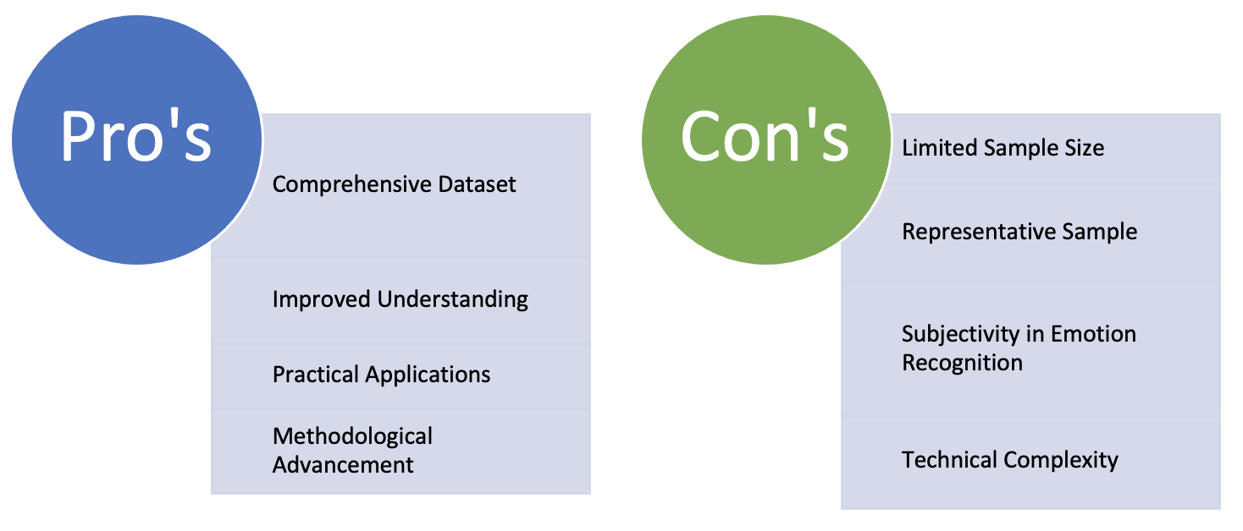

Figure 2 EmoReact Pro's and Con's

NoldusHub: is an all-in-one platform for human behaviour studies designed to combine multiple measurements and easily achieve reliable, high-quality data and direct insights. [14]

The Noldus Observer software allows researchers to capture, record, and analyse behavioural data from different sources. It supports video recording and analysis, enabling researchers to observe and code behaviours systematically and reliably. The software also provides tools for synchronisation with physiological data, eye tracking, and other biometric measurements.

# Project Ethics

When conducting a project involving public data, it is crucial to prioritise and uphold ethical considerations throughout the process.

To ensure the project's success, data must be collected from users engaging in video calls, and consent must be obtained to utilise the recorded data from these calls.

## Informed Consent:

For this project, obtaining informed consent from all participants is crucial. The Consent Form, provided in **Appendix A**, clearly outlines the project's purpose, procedures, potential risks, and benefits. Participants will have a comprehensive understanding of their rights, including the right to withdraw from the project at any time without facing any negative consequences. [16]

## Confidentiality and Anonymity:

Strict measures will be implemented to ensure the confidentiality and privacy of the research group participants. Personal information will be protected. Honouring participants' preferences regarding the use and storage of their data is crucial.

## Voluntary Participation:

Participation in the research project will be voluntary, without coercion or pressure. Participants will be free to choose whether or not to take part, and their decision will not result in any negative consequences or discrimination.

## Data Protection and Security:

Participants' data will be handled with the utmost care, adhering to relevant data protection regulations. Appropriate security measures will be implemented to prevent unauthorised access, use, or disclosure of sensitive information.

## Respect for Diverse Perspectives:

Recognising and respecting the diverse backgrounds, beliefs, and perspectives of the research group participants is crucial. It is essential to represent their views and experiences accurately without bias.

## Beneficence and Minimising Harm:

Efforts will be made to maximise potential benefits while minimising potential risks and harm to participants. Throughout the project, participants' well-being and emotional welfare will be monitored, and necessary support or referrals will be provided in case of any adverse effects during and after the video conference call.

## Transparency and Openness:

Maintaining transparency throughout the research project is vital. Clear communication regarding the objectives, methods, and expected outcomes will be promptly provided to participants and communicated in the consent form. Any questions or concerns they may have will be addressed promptly.

# Literature review

## Title: Development of Strategies for Automatic Facial Feature Extraction and Emotion Recognition

### Introduction:

Facial feature extraction and emotion recognition have gained significant attention in computer vision and affective computing. This literature review aims to explore the research paper titled "Development of Strategies for Automatic Facial Feature Extraction and Emotion Recognition" by David Restrepo and Alejandro Gómez [15]. The authors present their work on advancing the development of strategies for automatic facial feature extraction and emotion recognition. The review will provide an overview of the paper's objectives, methodologies, and critical findings while highlighting relevant related works.

### Summary of the Research Paper

The research paper focused on developing automatic facial feature extraction and emotion recognition strategies. The authors propose a novel approach combining computer vision and machine learning techniques to extract facial features and classify emotions.

The methodology involves face detection, feature extraction, and emotion classification. The authors also address challenges such as variations in facial expressions, lighting conditions, and occlusions.

### Facial Feature Extraction Techniques

The paper discusses various facial feature extraction techniques, such as geometric and appearance-based approaches. Geometric-based methods utilise facial landmarks or critical points to represent the face, while appearance-based methods use texture or appearance descriptors. The authors present a comprehensive analysis of these techniques and evaluate their effectiveness in terms of accuracy and computational complexity.

Several related studies have explored facial feature extraction techniques. For example, Zhang et al. [20] proposed a method based on facial landmarks to extract geometric features. Li et al. [11] introduced a hybrid approach combining geometric and appearance-based methods for improved feature extraction.

### Emotion Recognition:

The authors explored different emotion recognition approaches, including traditional machine learning methods and deep learning-based approaches. Traditional methods involve extracting handcrafted features and classification using classifiers such as support vector machines (SVM) or random forests. Deep learning approaches, on the other hand, utilise convolutional neural networks (CNN) to learn features directly from raw facial images. The authors compare the performance of these techniques and discuss their advantages and limitations.

Several notable studies have contributed to emotion recognition research. For instance, Jung et al. [6] proposed a deep learning-based approach using facial expression images for emotion classification. Zhao et al. [21] investigated the use of handcrafted features and SVM for emotion recognition from facial images.

### Discussion and Analysis:

The literature review section of the paper provides a comprehensive overview of the existing research in the field of automatic facial feature extraction and emotion recognition.

The authors discuss relevant studies contributing to developing facial feature extraction techniques and emotion classification models. They highlight the advancements made in the field and identify areas for further improvement.

### Evaluation and Results:

The research paper presented experimental results to evaluate the proposed automatic facial feature extraction and emotion recognition strategies.

The authors conducted experiments on publicly available datasets and reported performance metrics such as accuracy, precision, recall, and F1-score.

The results demonstrate the effectiveness of the proposed approach compared to existing methods, highlighting the potential for practical applications in real-world scenarios.

The authors validated their approach using widely used datasets such as the Cohn-Kanade [12] and the Extended Cohn-Kanade [7] databases.

### Critical Analysis:

The authors discuss various techniques for facial feature extraction, including geometric-based and appearance-based methods, and evaluate their effectiveness. They also explore different approaches to emotion recognition, including traditional machine learning and deep learning methods, and discuss their advantages and limitations.

The paper provides experimental results and evaluation metrics to support the proposed strategies. The review includes pioneering works such as the study by Ekman and Friesen [6], which laid the foundation for facial expression analysis and emotion recognition. Additionally, the authors discuss recent studies by Liu et al. [2] and Deng et al. [4], who proposed advanced techniques for facial feature extraction and emotion recognition using deep learning.

## Title: Literature Review: Reliable Emotion Recognition System Based on Dynamic Adaptive Fusion of Forehead Biopotentials and Physiological Signals

### Introduction:

Emotion recognition systems based on physiological signals have gained significant attention in affective computing. This literature review explores the research paper titled "Reliable Emotion Recognition System based on Dynamic Adaptive Fusion of Forehead Biopotentials and Physiological Signals" by Mahdi Khezria, Mohammad Firoozabadib, and Ahmad Reza Sharafat [8].

The paper presents an approach for reliable emotion recognition by dynamically fusing forehead biopotentials and physiological signals. This review provides an overview of the paper's objectives, methodologies, and critical findings while discussing related works in the field.

### Summary of the Research Paper:

The research paper focuses on developing a reliable emotion recognition system by combining forehead biopotentials, such as electroencephalography (EEG), and other physiological signals. The authors propose a methodology that includes signal acquisition, feature extraction, dynamic fusion, and classification.

The forehead biopotentials, and physiological signals are collected from participants during emotional stimuli. Relevant features are extracted, and a dynamic adaptive fusion algorithm combines the modalities effectively. Finally, a machine learning classifier is trained to recognise emotions based on the fused features.

### Physiological Signal Acquisition and Processing:

The paper discusses the acquisition and processing of physiological signals for emotion recognition. In addition to forehead biopotentials, various physiological signals, including electrocardiography (ECG), electrodermal activity (EDA), and electromyography (EMG), are commonly used. Signal pre-processing techniques, such as filtering, artefact removal, and normalisation, enhance the data quality. The authors comprehensively analyse the acquisition and processing methods, highlighting their relevance and impact on emotion recognition accuracy.

Several related studies have explored the use of physiological signals for emotion recognition. For example, Alarcao and Fonseca [10] investigated the utilisation of EDA for recognising emotional states. Valenza et al. [1] proposed a multimodal approach combining physiological signals and subjective self-reports for emotion recognition.

Dynamic Adaptive Fusion:

The authors propose a dynamic adaptive fusion algorithm to combine the information from forehead biopotentials and physiological signals effectively. The fusion algorithm dynamically adapts the weights assigned to each modality based on their relevance and contribution to emotion recognition. This dynamic fusion strategy aims to optimise the classification performance and enhance the reliability of the emotion recognition system.

Machine Learning Classification:

The paper discusses the implementation of machine learning classifiers for emotion recognition. Various algorithms are commonly employed, such as support vector machines (SVM), random forests (RF), and neural networks. The authors evaluate the performance of different classifiers and investigate their suitability for reliable emotion recognition based on the fused features.

### Evaluation and Results:

The research paper presents experimental results to evaluate the proposed reliable emotion recognition system. The authors conduct experiments on publicly available datasets and report performance metrics such as accuracy, precision, recall, and F1-score. The results demonstrate the effectiveness of the proposed approach, highlighting its reliability in recognising emotions compared to existing methods.

Conclusion and Future Directions:

The research paper's conclusion summarises the study's essential findings and contributions. The authors emphasise the importance of reliable emotion recognition systems in various applications, such as healthcare, human-computer interaction, and affective computing. They discuss potential future directions, including exploring advanced machine learning algorithms and integrating additional modalities for enhanced emotion recognition.

### Critical Analysis:

The research paper provides valuable insights into developing a reliable emotion recognition system based on dynamic adaptive fusion. The authors demonstrate a thorough understanding of the existing literature in the field and present a well-structured methodology. However, it is vital to consider the limitations of the proposed approach and potential challenges associated with real-world implementation, which could be addressed in future research.

### Significance and Impact:

The research paper contributes to advancing reliable emotion recognition systems by combining forehead biopotentials and physiological signals. The findings of this study can be valuable for various domains, including healthcare, psychology, and affective computing.

The proposed approach could enhance the accuracy and reliability of emotion recognition systems, leading to improved human-computer interaction and personalised services.

## Title: Literature Review: Fast and Accurate Sentiment Classification using an Enhanced Naive Bayes Model

### Introduction:

Sentiment classification, or opinion mining, plays a crucial role in analysing and understanding people's opinions and sentiments. This literature review focuses on the "Fast and Accurate Sentiment Classification using an Enhanced Naive Bayes Model" research paper by Vivek Narayanan, Ishan Arora, and Arjun Bhatia [1].

The paper presents an approach for sentiment classification that enhances the traditional Naive Bayes model to achieve faster and more accurate sentiment analysis. This review provides an overview of the paper's objectives, methodologies, and critical findings while discussing related works in the field.

### Summary of the Research Paper:

The research paper aims to improve the speed and accuracy of sentiment classification using an enhanced Naive Bayes model. The authors propose several enhancements to the traditional Naive Bayes classifier, including feature selection, transformation, and model optimisation. The methodology involves pre-processing the text data, extracting relevant features, and training the Naive Bayes classifier with enhanced techniques. The authors evaluate the performance of their approach on standard sentiment classification datasets and compare it with existing methods.

### Sentiment Classification with Naive Bayes:

The paper discusses the use of the Naive Bayes algorithm for sentiment classification. Naive Bayes is a probabilistic classifier that calculates the likelihood of a document belonging to a particular sentiment class based on the occurrence of words or features. The authors explain the underlying assumptions of the Naive Bayes model and its suitability for sentiment analysis tasks. They also discuss the challenges of using Naive Bayes and propose enhancements to address these limitations.

### Enhanced Techniques:

The authors propose several techniques to enhance the Naive Bayes model for sentiment classification. Feature selection methods, such as information gain or chi-square statistics, are employed to select the most informative features from the text data. Feature transformation techniques, such as term frequency-inverse document frequency (TF-IDF) weighting, are applied to capture the importance of features in sentiment classification. The authors also optimise the Naive Bayes model by incorporating Laplace smoothing and handling unknown words.

### Related Works:

The literature review section of the paper provides an overview of related works in the field of sentiment classification. The authors discuss previous studies that have explored different machine learning algorithms, such as support vector machines (SVM), decision trees, and deep learning models, for sentiment analysis. They highlight the advantages and limitations of these approaches and position their enhanced Naive Bayes model as a competitive solution.

### Evaluation and Results:

The research paper presents experimental results to evaluate the proposed enhanced Naive Bayes model for sentiment classification. The authors conduct experiments on benchmark sentiment classification datasets, such as the Movie Review or the Twitter Sentiment dataset, and report performance metrics, such as accuracy, precision, recall, and F1-score. The results demonstrate that the enhanced Naive Bayes model outperforms traditional Naive Bayes and other state-of-the-art sentiment classification methods regarding speed and accuracy.

### Conclusion and Future Directions:

The research paper's conclusion summarises the study's essential findings and contributions. The authors emphasise the significance of their enhanced Naive Bayes model in achieving fast and accurate sentiment classification. They discuss potential future research directions, including exploring additional feature engineering techniques, incorporating contextual information, and integrating other machine learning algorithms for sentiment analysis.

### Critical Analysis:

The research paper provides valuable insights into improving sentiment classification using an enhanced Naive Bayes model. The authors demonstrate a sound understanding of sentiment analysis techniques and present a well-structured methodology. However, it would be beneficial for future work to discuss potential limitations and challenges associated with their approach and provide insights into the interpretability of the model.

### Significance and Impact:

The research paper contributes to advancing sentiment classification techniques by proposing enhancements to the traditional Naive Bayes model. The findings of this study have practical implications in various domains, such as social media analysis, customer feedback analysis, and market research. The enhanced Naive Bayes model offers a fast and accurate solution for sentiment analysis, facilitating decision-making processes and providing valuable insights into people's opinions and sentiments.

# Project Proposal and Design

## Topic Area

Machine learning and neural networks using a public dataset this proposal includes choosing, based on a quantitative evaluation, a well-performing machine learning model for use with a publicly available dataset.

## Title

**A feeling index** - to be used to score interactions in video conferencing calls.

## Project Background – Domain and Users

The template for **CM3015 Machine Learning and Neural Networks**, titled "**Deep Learning on a Public Dataset**," will be utilised.

As mentioned in the introduction, the proposal is to develop an emotional/feeling index based on emotional recognition and sentiment analysis based on the behaviour and speech of a user during a video call.

The project involves conducting emotional recognition and sentiment analysis in video call meetings. It aims to investigate facial expressions and speech patterns to enhance communication. The project will employ neural networks and deep learning models for sentiment analysis.

This project idea involves exploring the potentials of deep learning techniques, specifically Convolutional Neural Networks (CNNs), for image recognition tasks using a dataset containing thousands of images with emotional classifications like ['Angry', 'Disgust', 'Fear', 'Happy', 'Sad', 'Surprise', 'Neutral']. The sentiment analysis will be done using deep learning models with neural networks.

The domain of the project is for affective computing and emotion recognition. Affective computing focuses on developing systems that can detect, interpret, and respond to human emotions. This involves analysing and understanding the emotions expressed by individuals through facial expressions and the sentiment conveyed through their spoken words.

As for the users of the project, they could vary depending on the specific application or context. Here are a few potential user groups:

* Therapists or Counselors
* Content Creators
* Customer Experience Analysts
* Employees in video conference calls

## Skills and technologies required for project completion

During the development of this project, the application of computing, machine learning, and neural network model-building techniques, as well as acquired skills in information technology, technical expertise, and business acumen, will be employed to implement a high-quality final product.

Some of these will include;

Project Management: The experience and knowledge of project management will be utilised to organise and manage resources, ensuring the project is completed within the defined scope, quality, and time constraints. Monday.com will be utilised for this purpose, as seen in **Appendix B**.

Software Engineering Methodology: Leveraging previous skills in software engineering, software engineering methodologies will be identified and applied to project development. Python will be used for analysis, specification, design, coding, and testing, ensuring quality assurance for the code and model outputs.

Programming Language: The project models will be developed using python, requiring proficiency in programming languages. Over time, knowledge and understanding of these languages have been acquired. An in-depth study of python and the necessary libraries will be undertaken to accomplish this project. This includes libraries such as TensorFlow, PyTorch, and Pandas, which are crucial for creating, training, and testing the models.

Understanding Deep Learning Models: Building a deep learning model requires combining skills from various domains. Understanding deep learning concepts includes knowledge of neural networks, activation functions, loss functions, optimisation algorithms, and backpropagation. In addition, an evaluation will be performed on various deep learning architectures, including convolutional neural networks (CNNs), recurrent neural networks (RNNs), and generative adversarial networks (GANs). This evaluation will be conducted for the emotional recognition and sentiment analysis models.

Machine Learning Concepts: A good understanding of general machine learning concepts, such as supervised and unsupervised learning, overfitting, underfitting, cross-validation, and model evaluation metrics, is valuable when building deep learning models

### The dataset used:

Dataset: FERV39k The project will use a publicly available dataset, such as the Extended Cohn-Kanade Dataset (CK+), which includes images of facial expressions of individuals labelled with one of the seven emotional states listed in the project background. The dataset can be augmented to include pictures of faces with beards, glasses, and other common variations.

Access to the dataset has been requested from Yan Wang (Post Doctor Fellow) via email, and the dataset has been provided for download. Please refer to Appendix C for further details. <https://github.com/wangyanckxx/FERV39k>

### Features

The feeling index, which will show the classification of the video conferencing call, will be built based on emotional recognition.

This will be based on images extracted from a live video call and sentiment analysis for each spoken sentence. The image extracted will be in the mean of when the sentence was spoken. If the sentence starts at 01:02 min and stops at 01:04, the image collected will be at 01:03. The sentiment and the emotion will be mapped to a weightage assigned, and the total score will show based on the max emotions and sentiment detected for the duration of the call.

### Researching

The initial project proposal research will be based on the following research papers below, covered in the literature review section, and include comprehensive research.

1. M. Soleymani, D. Garcia, B. Jou, S. Schuller, and T. Pun, "A multimodal dataset for authoring and analysis of affective behavior," in Proceedings of the 9th IEEE Conference on Face and Gesture Recognition (FG), 2019.

Research article citation:

2. S. Soleymani, T. Pun, and M. Soleymani, "EmoReact: A Multimodal Approach and Dataset for Recognising Emotional Responses in Children," in Proceedings of the 21st ACM International Conference on Multimodal Interaction (ICMI), 2019, pp. 516-520.

3. Ma, X., Zhang, Y., Jiang, X., Wang, Y., & Li, W. (2021). Affective computing in video conference: A survey. IEEE Transactions on Affective Computing, 12(1), 36-56.

4. McDuff, D., Kaliouby, R. E., & Picard, R. W. (2015). Crowdsourcing facial responses to online videos. IEEE Transactions on Affective Computing, 6(1), 81-95.

5. Khan, S., & Zhang, S. (2019). A survey of affect recognition methods: Audio, visual, and spontaneous expressions. IEEE Transactions on Affective Computing, 10(3), 374-390.

6. Kim, K. H., Bang, S. W., & Kim, S. R. (2017). Emotion recognition using facial expression and speech prosody for a conversational agent. IEEE Transactions on Consumer Electronics, 63(3), 295-302.

## 

### Required Resources

The internet, libraries, research papers, python, hardware and software (Personal computer) for video calls as well as developing the models, understanding model building and neural networks and deep learning models.

## Planned Tasks and Project Plan

The planned tasks for the project have been laid out in the project plan in **Appendix D**, with weekly updates being made and task tracking. **Appendix F**, For a quick view, see below:

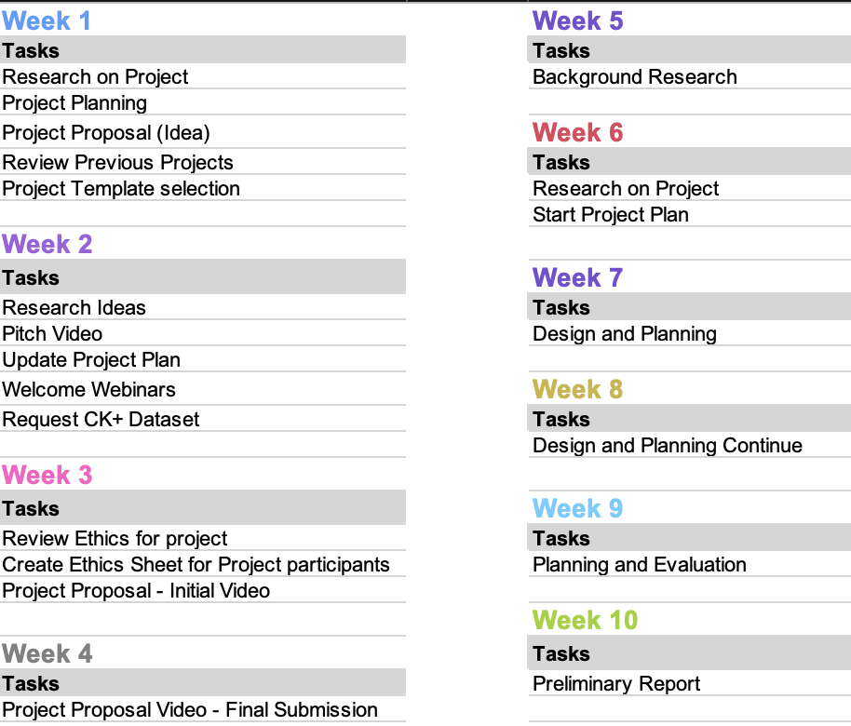

Figure 3 Project Tasks - See Appendix D and E

## Project Design Steps

The design and steps for creating the feeling index score are as follows:

1. Relevant emotional states and sentiment categories will be identified. In this case, the relevant emotional states are 'Angry', 'Disgust', 'Fear', 'Happy', 'Sad', 'Surprised', and 'Neutral', and the sentiment categories are Positive, Negative, and Neutral.
2. The weights or importance of each emotional state and sentiment category will be determined. This can be done by expert judgment, statistical analysis, or stakeholder consultation. For example, 'Happy' is +3, 'Neutral' is +1, 'Surprise' is +1, 'Sad' is -1, 'Fear' is -2, 'Disgust' is -3, and 'Angry' is -3. For sentiment analysis, weight positive sentiment as +1, negative sentiment as -1, and neutral sentiment as 0.
3. The candidate recordings will be obtained, and the data will be collected and pre-processed with the consent signed. This involves collecting images of facial expressions and text data that reflect individuals' emotional and sentiment responses during video calls. The data should be labelled with the relevant emotional states and sentiment categories.
4. The first thing is to conduct facial emotion recognition and sentiment analysis on the data. This will be done using machine learning algorithms such as CNNs for facial emotion recognition and natural language processing techniques for sentiment analysis. The output should be a set of scores that reflect the intensity or frequency of each emotional state and sentiment category.
5. After all the data is collected and scored, normalise the scores. The scores may have different scales or ranges, so they must be transformed or standardised to make them comparable. This can be done by subtracting and dividing the mean by the standard deviation or by scaling the data to an expected range.
6. The scores will be combined into a composite index score. This will involve adding the weighted scores for each category and merging the facial emotion recognition and sentiment analysis scores.
7. The index score will be validated to ensure its viability and validity. This will include testing its accuracy in reflecting individuals' emotional and sentiment responses. Validation methods may involve statistical analysis, sensitivity testing, or expert review.

In summary, developing a feelings score using facial emotional recognition and sentiment analysis outcomes involves identifying relevant emotional states and sentiment categories, assigning weights, collecting, and pre-processing data, conducting facial emotion recognition and sentiment analysis, normalising the scores, combining the scores into a composite index score, and validating the index score.

## Test Plan/Evaluation Strategy for the Project

This test plan aims to verify the accuracy and functionality of the combined facial emotion recognition and sentiment analysis model in generating an emotional score.

The accuracy and functionality of a combined facial emotion recognition and sentiment analysis model will be based on the following **test cases**:

### Test Case 1: Facial Emotion Recognition

Description: Test the accuracy of the facial emotion recognition model.

Inputs: Images or video samples with known emotional expressions

Expected Output: Correct classification of emotional expressions (e.g., happiness, sadness, anger)

### Test Case 2: Sentiment Analysis

* Description: Test the accuracy of the sentiment analysis model.
* Inputs: Text samples with known sentiment (positive, negative, neutral)
* Expected Output: Correct classification of sentiment in the text samples

### Test Case 3: Integration of Facial Emotion Recognition and Sentiment Analysis

* Description: Test the integration of both models to generate an emotional score.
* Inputs: A combined dataset of images/videos and corresponding text
* Expected Output: Accurate emotional scores reflecting the combined facial emotion recognition and sentiment analysis

### Test Case 4: Weighting and Calibration

* Description: Test the weighting of the facial emotion recognition and sentiment analysis models and the calibration of the emotional score.
* Inputs: Datasets with known emotional scores and corresponding ground truth
* Expected Output: Well-calibrated emotional scores with an appropriate weighting of facial and textual components

### Test Case 5: Performance and Scalability

* Description: Test the performance and scalability of the combined model.
* Inputs: Varying dataset sizes and complexities
* Expected Output: Timely and accurate emotional score generation, even with large datasets

### Test Execution:

1. Prepare test datasets with known emotional expressions and sentiment labels.
2. Execute each test case, comparing the actual outputs with the expected outputs.
3. Record and analyse the results for each test case.
4. Document any discrepancies, errors, or issues encountered during testing.

### Test Reporting:

* Generate a test report summarising the results, including any deviations from expected outcomes.
* Document any bugs, errors, or performance issues observed during testing.
* Provide recommendations for improvements or enhancements based on the test findings.

By following the test plan and executing the outlined test cases, the individual can assess the accuracy, reliability, and performance of the combined facial emotion recognition and sentiment analysis model, thereby ensuring its effectiveness in generating meaningful emotional scores.

# Project Prototype

The template for CM3015 Machine Learning and Neural Networks, titled "Deep Learning on a Public Datase” will be used for the prototype as well as the final project. There is a complete jupyter notebook with comments and explanation on the protype availible, Appendix G contains the snippet with all outlines steps followed.

## Features Implemented in the Prototype:

Facial Emotion Recognition: The prototype uses Convolutional Neural Networks (CNNs) and the Extended Cohn-Kanade Dataset (CK+) to recognize facial expressions in video frames. It detects emotions such as anger, disgust, fear, happiness, sadness, surprise, and neutral.

Sentiment Analysis: Natural Language Processing techniques are employed to analyze the sentiment of the spoken sentences during the video call. The prototype uses the Whisper model from OpenAI to perform sentiment analysis and assign sentiment scores to each sentence.

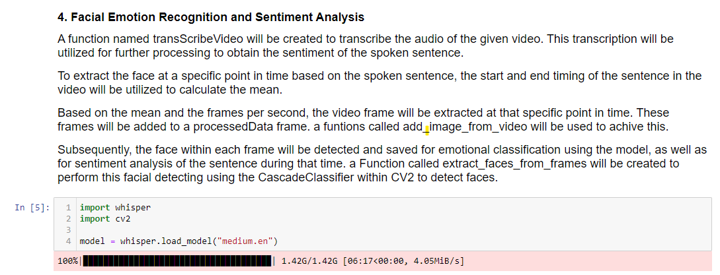

Figure 4 Notebook snippet showing Wisper model

Composite Index Score: The emotional scores from facial emotion recognition and sentiment analysis are combined to generate a composite index score. This score represents the overall emotional state during the video call.

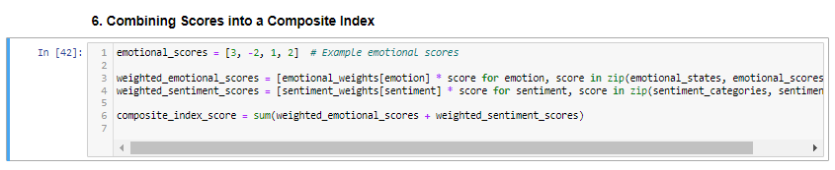

Figure 5 Notebook Snippet - Composite index score

## Algorithms, Techniques, and Methods Used:

Convolutional Neural Networks (CNNs): CNNs are utilized for facial emotion recognition. These deep learning models are well-suited for image recognition tasks and can effectively classify facial expressions.

Natural Language Processing (NLP): NLP techniques are applied for sentiment analysis of the spoken sentences. The prototype employs the Whisper model from OpenAI, which is based on transformer architectures and trained on a large corpus of text data.

Haar Cascades Algorithm: The Haar cascades algorithm, implemented in the OpenCV library, is used for face detection in video frames. It employs a set of pre-trained classifiers to detect faces accurately.

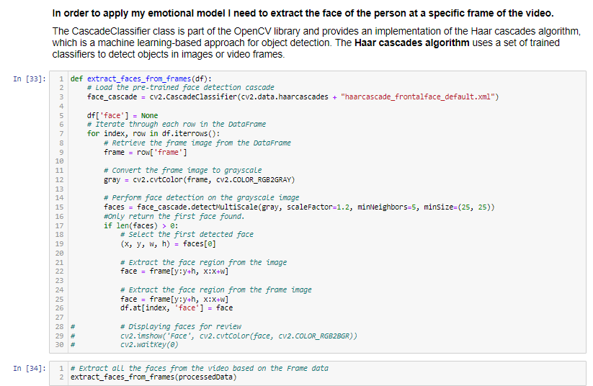

Figure 6Notebook Snippet - Showing face detection and extraction.

## Explanation of the Code:

The provided code in Appendix G. includes several important sections:

Data Preprocessing: The code preprocesses the spoken sentences from the video call by removing stopwords, punctuation, and performing lemmatization. This step is crucial for accurate sentiment analysis.

Facial Emotion Recognition: The code extracts frames from the video at the mean time of each spoken sentence. It then applies the Haar cascades algorithm to detect faces in the frames. The detected face regions are used as inputs to the CNN model for facial emotion recognition.

Sentiment Analysis: The code utilizes the Whisper model to perform sentiment analysis on the preprocessed spoken sentences. It generates sentiment scores for each sentence.

Composite Index Score: The code combines the emotional scores from facial emotion recognition and sentiment analysis, applying the assigned weights to each emotion and sentiment category. The resulting composite index score represents the overall emotional state during the video call.

## Visual Representation:

The prototype does not provide a user interface, as it focuses on the underlying functionality. However, screenshots or visualizations can be included in the final project to showcase the results and user interactions.

## Evaluation and Future Improvements:

The prototype demonstrates the feasibility of extracting emotional scores from video calls using facial emotion recognition and sentiment analysis. However, the success of the prototype can be further evaluated by testing it with a diverse range of video call scenarios and comparing the generated emotional scores with human evaluations.

**To improve the prototype, the following steps can be taken:**

1. Improve Facial Emotion Recognition: Experiment with different deep learning architectures, such as recurrent neural networks (RNNs) or generative adversarial networks (GANs), to enhance facial emotion recognition accuracy.

2. Enhance Sentiment Analysis: Explore advanced NLP techniques, including contextual embeddings and attention mechanisms, to improve sentiment analysis accuracy and capture the nuances of spoken language.

3. User Interface Development: Create an interactive and user-friendly interface that allows users to upload their own video calls, view emotional scores, and visualize the emotional state over time.

4. Real-time Processing: Optimize the prototype to perform real-time processing of video calls, enabling users to receive emotional scores and feedback during the call itself.

By addressing these improvements, the prototype can be transformed into a robust and user-friendly tool that provides valuable insights into the emotional dynamics of video conferencing calls.

# Product Development Process - **PLACEHOLDER**

## Design model

## Architecture Description

## UI Design

# Implementation - **PLACEHOLDER**

## Implementation Requirements

# Project Overview and Conclusion - **PLACEHOLDER**

# Appendix A: Consent Form

[16]



# Appendix B: Project Gant Chart

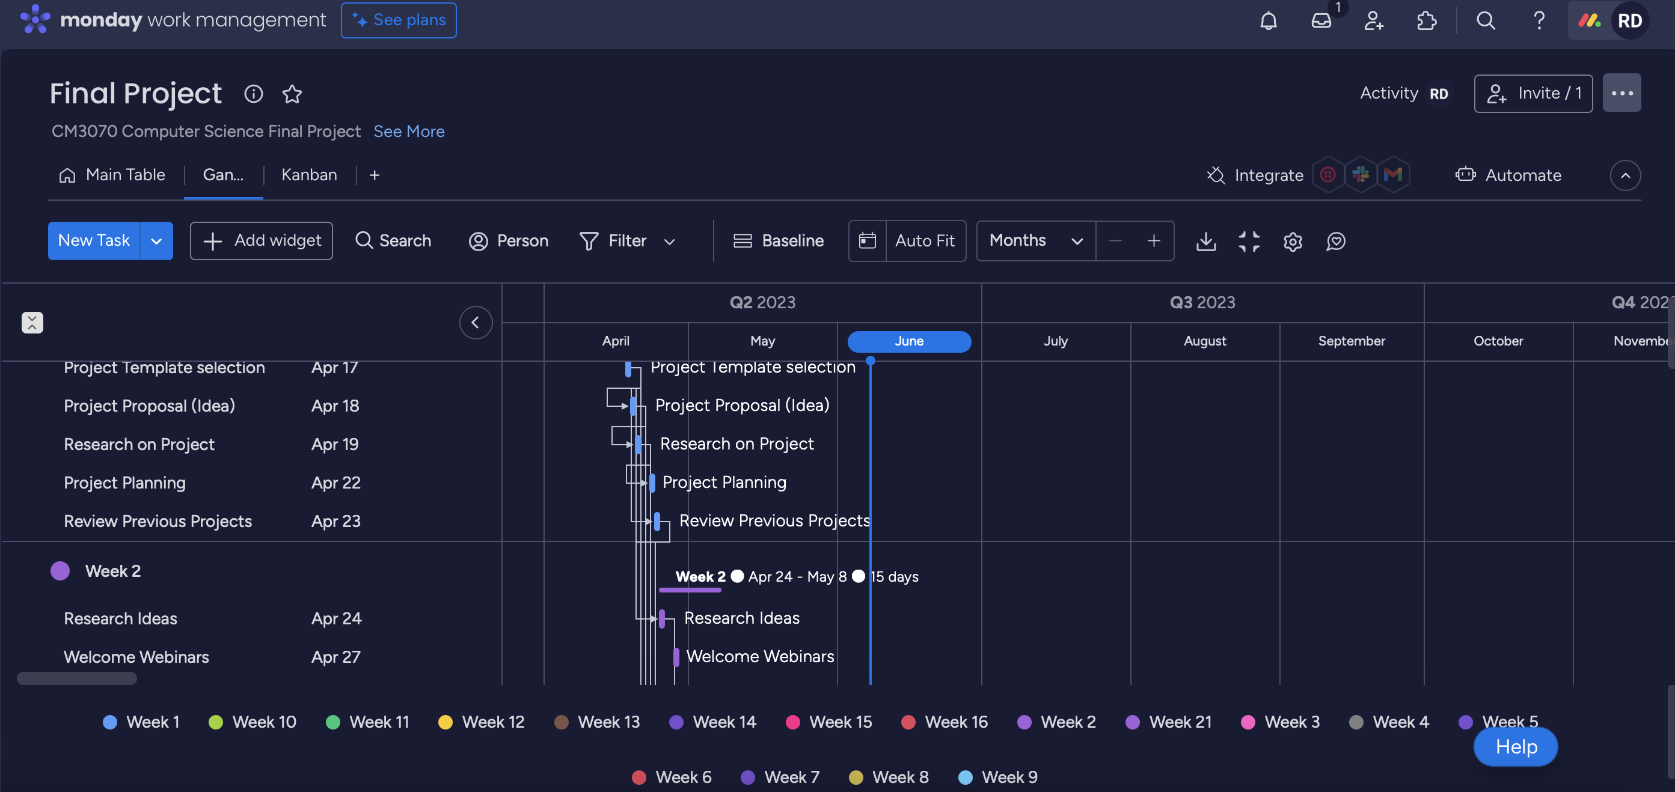

Figure 7 Project Plan

# Appendix C: Dataset Permission

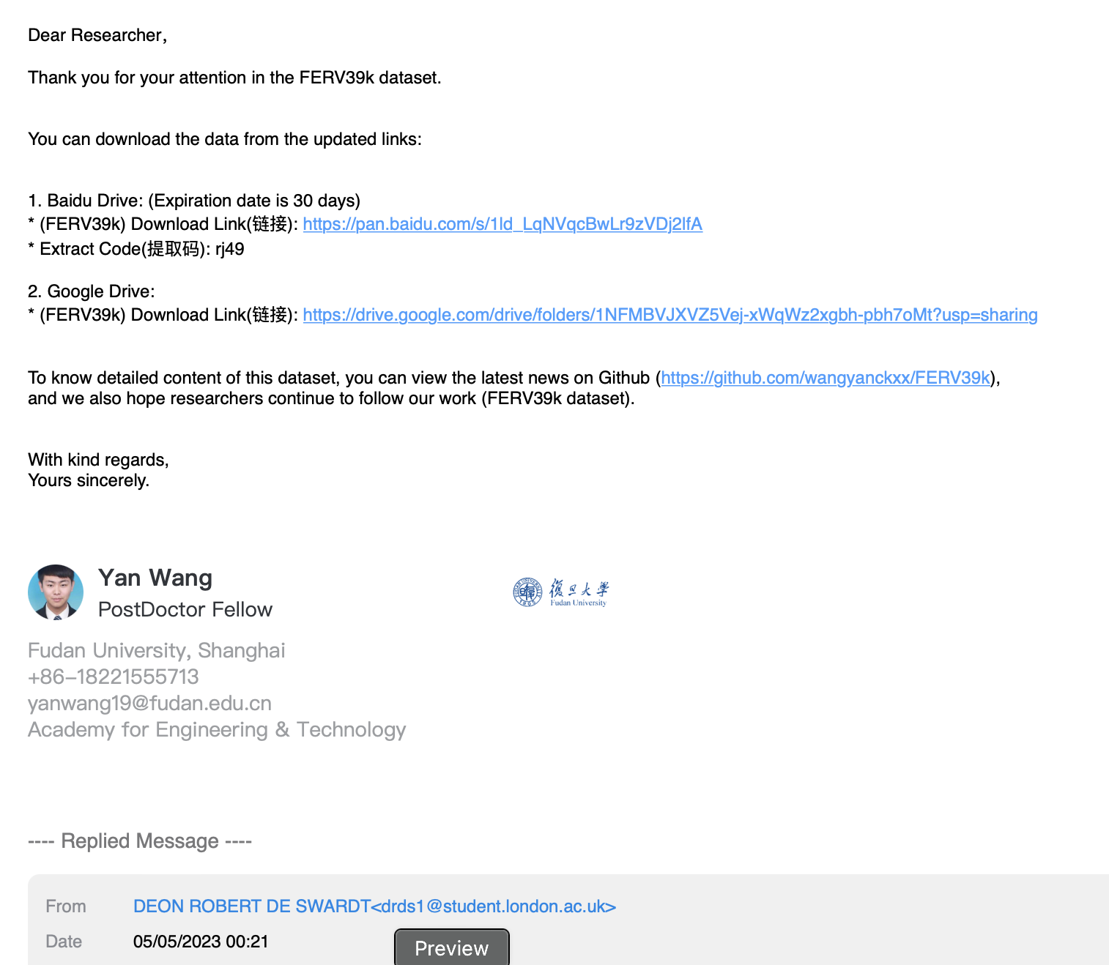

Figure 8 Requested DataSet access

# Appendix D: Project Plan

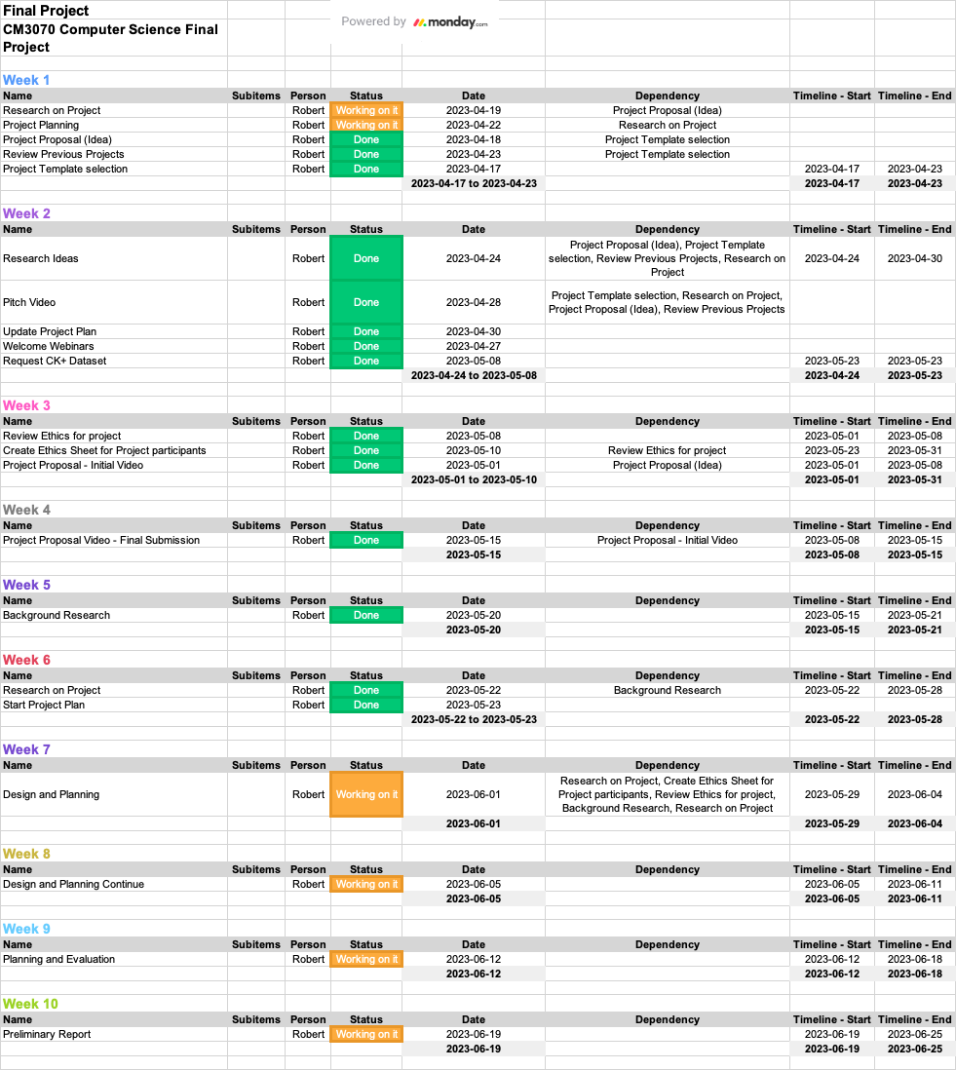

# Appendix E: Timeline

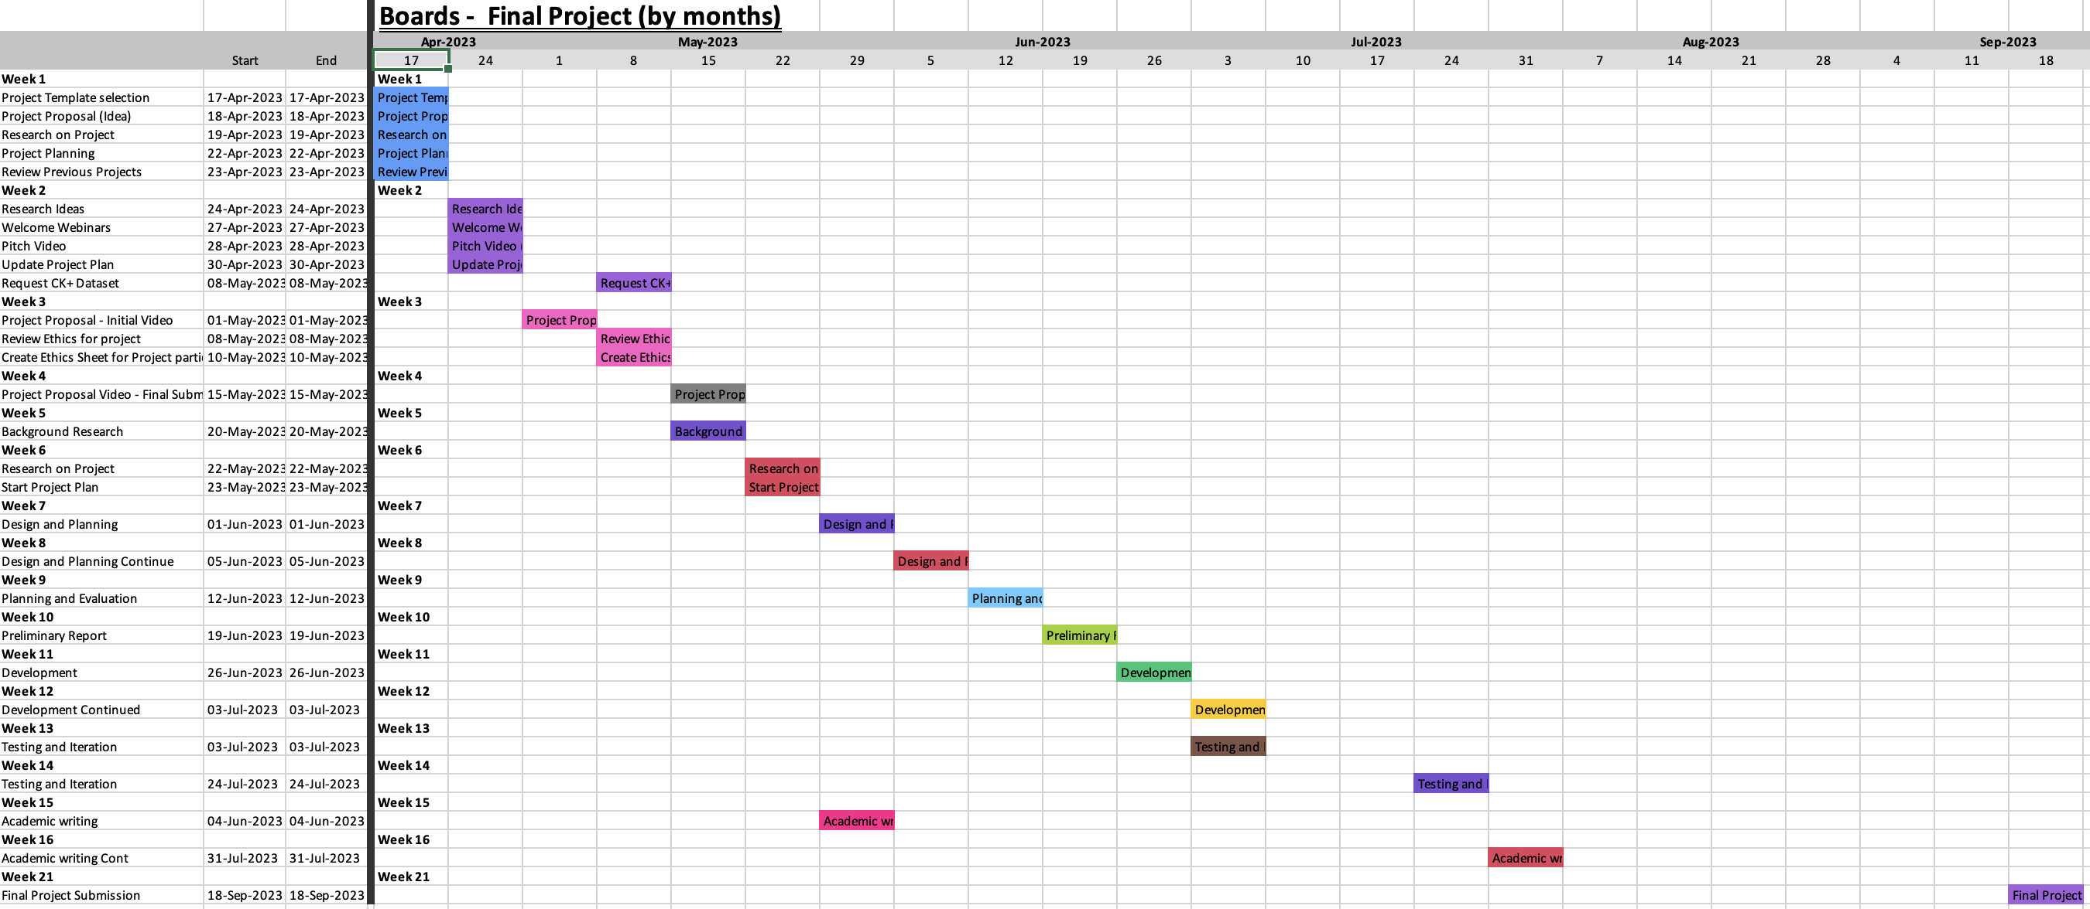

# Appendix F: Kanban View

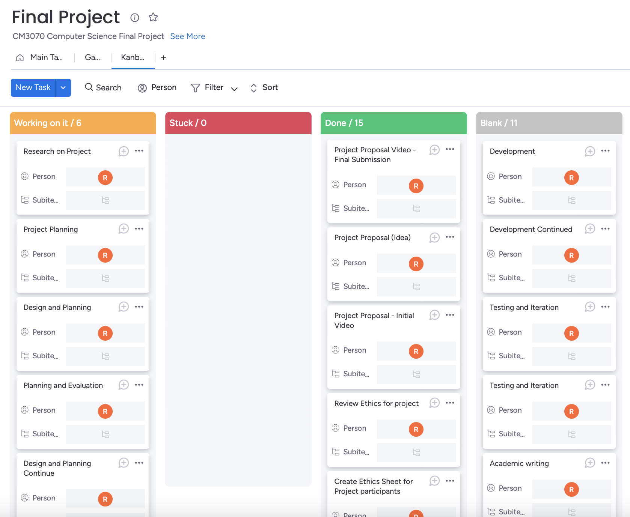

# Appendix G: Python Jupyter Notebook

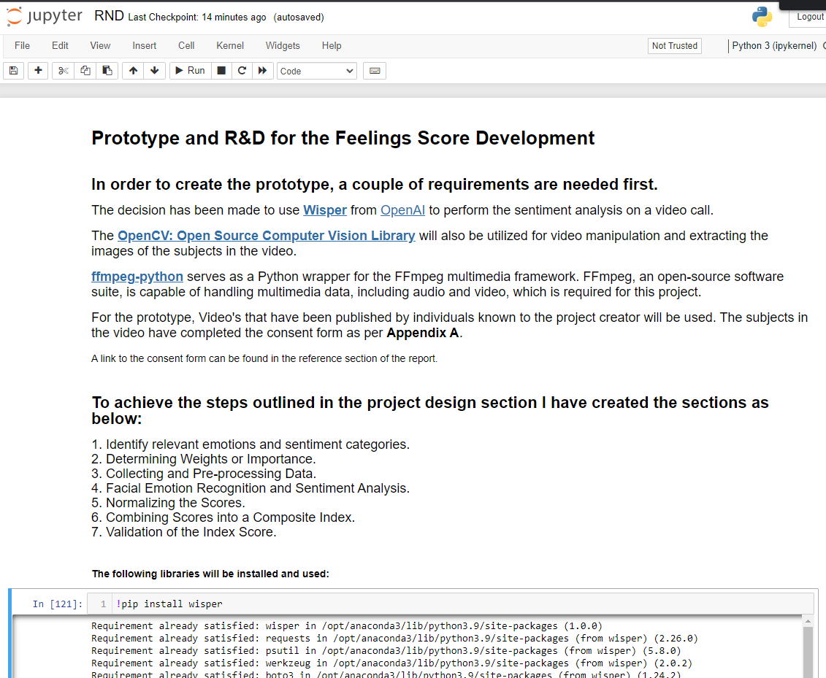

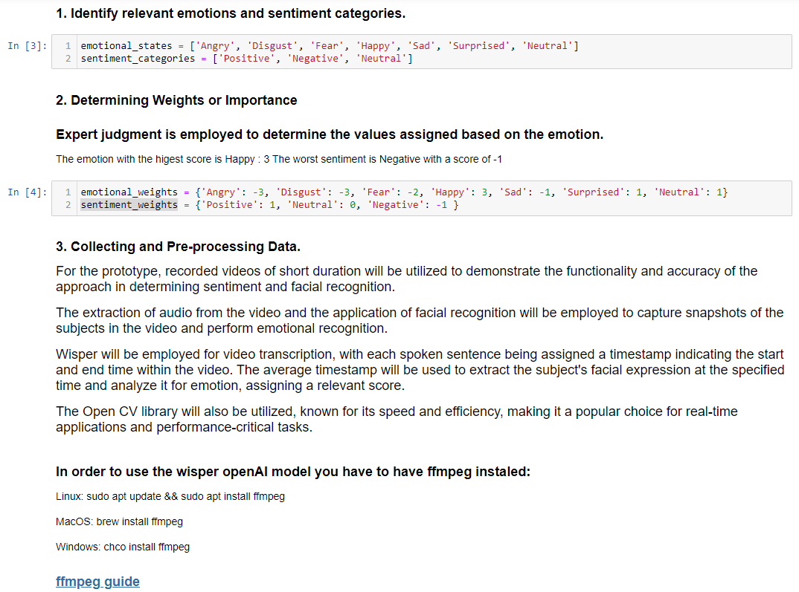

# References

[1] CHANEL, G., KRONEGG, J., GRANDJEAN, D. AND PUN, T. 2006. Emotion Assessment: Arousal Evaluation Using EEG's and Peripheral Physiological Signals. 530. .

[2] CLARK, E.A., KESSINGER, J., DUNCAN, S.E., BELL, M.A., LAHNE, J., GALLAGHER, D.L. AND O&#39;KEEFE, S.F. 2020. The Facial Action Coding System for Characterization of Human Affective Response to Consumer Product-Based Stimuli: A Systematic Review. *Frontiers in psychology* 11, 920. <https://search.proquest.com/docview/2412984813.>

[3] DOMÍNGUEZ-JIMÉNEZ, J.A., CAMPO-LANDINES, K.C., MARTÍNEZ-SANTOS, J.C., DELAHOZ, E.J. AND CONTRERAS-ORTIZ, S.H. 2020. A machine learning model for emotion recognition from physiological signals. *Biomedical signal processing and control* 55, 101646. <https://dx.doi.org/10.1016/j.bspc.2019.101646.>

[4] GU, J., WANG, Z., KUEN, J., MA, L., SHAHROUDY, A., SHUAI, B., LIU, T., WANG, X., WANG, G., CAI, J. AND CHEN, T. 2018. Recent advances in convolutional neural networks. *Pattern recognition* 77, 354-377. <https://dx.doi.org/10.1016/j.patcog.2017.10.013.>

[5] HTTPS://IMOTIONS.COM/ABOUT-US/. About Us - iMotions. 2023, .

[6] JUNG, H., LEE, S., YIM, J., PARK, S. AND KIM, J. Dec 01, 2015. Joint Fine-Tuning in Deep Neural Networks for Facial Expression Recognition. In Anonymous IEEE, , 2983-2991.

[7] KANADE, T., COHN, J.F. AND YINGLI TIAN. 2000. Comprehensive database for facial expression analysis. In Anonymous IEEE, , 46-53.

[8] KHEZRI, M., FIROOZABADI, M. AND SHARAFAT, A.R. 2015. Reliable emotion recognition system based on dynamic adaptive fusion of forehead biopotentials and physiological signals. *Computer methods and programs in biomedicine* 122, 149-164. <https://www.clinicalkey.es/playcontent/1-s2.0-S0169260715001959.>

[9] KOELSTRA, S., MUHL, C., SOLEYMANI, M., JONG-SEOK LEE, YAZDANI, A., EBRAHIMI, T., PUN, T., NIJHOLT, A. AND PATRAS, I. 2012. DEAP: A Database for Emotion Analysis ;Using Physiological Signals. *IEEE TRANSACTIONS ON AFFECTIVE COMPUTING* 3, 18-31. <https://ieeexplore.ieee.org/document/5871728.>

[10] KOELSTRA, S., MUHL, C., SOLEYMANI, M., JONG-SEOK LEE, YAZDANI, A., EBRAHIMI, T., PUN, T., NIJHOLT, A. AND PATRAS, I. 2012. DEAP: A Database for Emotion Analysis ;Using Physiological Signals. *IEEE TRANSACTIONS ON AFFECTIVE COMPUTING* 3, 18-31. <https://ieeexplore.ieee.org/document/5871728.>

[11] LIU, Q., YANG, J., DENG, J. AND ZHANG, K. 2017. Robust facial landmark tracking via cascade regression. *Pattern recognition* 66, 53-62. <https://dx.doi.org/10.1016/j.patcog.2016.12.024.>

[12] LUCEY, P., COHN, J.F., KANADE, T., SARAGIH, J., AMBADAR, Z. AND MATTHEWS, I. 2010. The Extended Cohn-Kanade Dataset (CK+): A complete dataset for action unit and emotion-specified expression. .

[13] NOJAVANASGHARI, B., BALTRUŠAITIS, T., HUGHES, C.E. AND MORENCY, L. Oct 31, 2016. EmoReact: a multimodal approach and dataset for recognizing emotional responses in children. In Anonymous ACM, , 137-144.

[14] NOLDUSHUB. Noldus. 2023, .

[15] RESTREPO, D. AND GOMEZ, A. Oct 2017. Short Research Advanced Project: Development of strategies for automatic facial feature extraction and emotion recognition. In Anonymous IEEE, , 1-6.

[16] ROBERT DE SWARDT. 2023. Consent Form. 2023, .

[17] SHU, L., XIE, J., YANG, M., LI, Z., LI, Z., LIAO, D., XU, X. AND YANG, X. 2018. A Review of Emotion Recognition Using Physiological Signals. *Sensors (Basel, Switzerland)* 18, 2074. <https://www.ncbi.nlm.nih.gov/pubmed/29958457.>

[18] WANG, F., WU, S., ZHANG, W., XU, Z., ZHANG, Y., WU, C. AND COLEMAN, S. 2020. Emotion recognition with convolutional neural network and EEG-based EFDMs. *Neuropsychologia* 146, 107506. <https://dx.doi.org/10.1016/j.neuropsychologia.2020.107506.>

[19] WANG, Z., WANG, Y., ZHANG, J., HU, C., YIN, Z. AND SONG, Y. 2022. Spatial-Temporal Feature Fusion Neural Network for EEG-Based Emotion Recognition. *IEEE transactions on instrumentation and measurement* 71, 1-12. <https://ieeexplore.ieee.org/document/9751142.>

[20] ZHANG, Z., LUO, P., LOY, C.C. AND TANG, X. 2014. Facial Landmark Detection by Deep Multi-task Learning. 94. .

[21] ZHAO, X. AND ZHANG, S. 2011. Facial Expression Recognition Based on Local Binary Patterns and Kernel Discriminant Isomap. *Sensors (Basel, Switzerland)* 11, 9573-9588. <https://www.ncbi.nlm.nih.gov/pubmed/22163713.>

stylefix